Docker Artifactory integration

Artifactory lets you use repositories as fully-fledged [Docker](https://docker.com/) registry in every way.

Artifactory can be installed via

1. Docker image

* docker pull jfrog-docker-reg2.bintray.io/jfrog/artifactory-registry:<version>
* docker run --name <container name> -p 8081:8081 <volume mounts> jfrog-docker-reg2.bintray.io/jfrog/artifactory-<oss|pro|registry>:<version>
* Install the license

For pushing the docker images.

<https://www.jfrog.com/confluence/display/RTF/Running+with+Docker>

the above link should be read along with the document to understand more.

Using Artifactory as docker image has the advantage that reverse proxy is configured by default and a number of repositories are created by default.

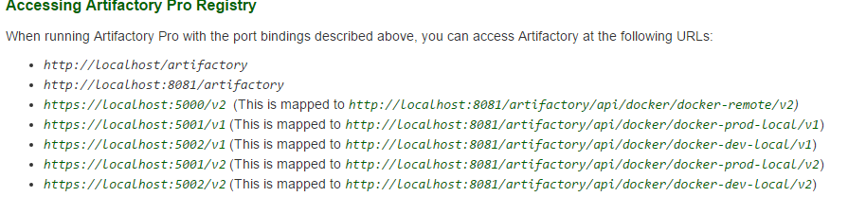

Change the permission of repository to give permission for anonymous users to access the repository.

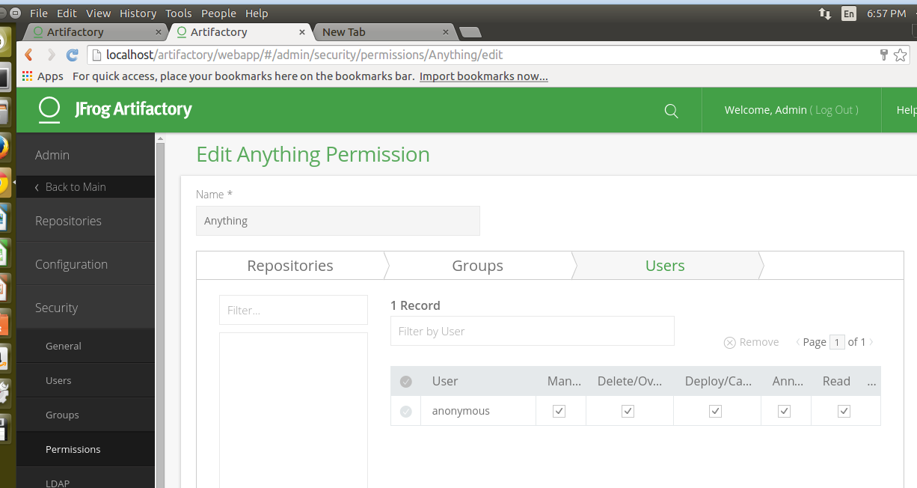

Suppose you want to push to a docker-dev-local repository inside Artifactory.

Following steps to be followed for pushing to repository

* First set insecure registry flag in /etc/default/docker file so as to access by http not https inside

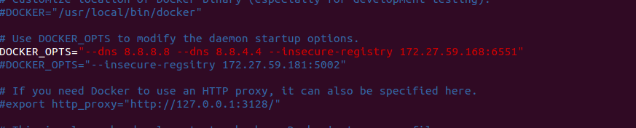

* docker tag image localhost:5002/image
* docker push localhost:5002/image

<https://www.jfrog.com/video/install-artifactory-docker-registry-one-minute-less/>

The above link explains the procedure very clearly.

1. As docker zip file download and run in web server
2. [Create a local repository](https://www.jfrog.com/confluence/display/RTF/Docker+Repositories#DockerRepositories-2.CreatingaLocalDockerRepository)
3. [Set up a web server as a reverse proxy](https://www.jfrog.com/confluence/display/RTF/Docker+Repositories#DockerRepositories-1.SettingupNGINXasaReverseProxy) (you can skip this step if you are working with Artifactory Online)
4. [Set up authentication](https://www.jfrog.com/confluence/display/RTF/Docker+Repositories#DockerRepositories-3.SettingUpAuthentication)
5. [Push and pull images](https://www.jfrog.com/confluence/display/RTF/Docker+Repositories#DockerRepositories-4.PushingandPullingImages)

Step.1

Creating a Local Docker Repository

To create a local Docker repository to host your Docker images, create a new Local Repository and set **Docker**as the**Package Type.**

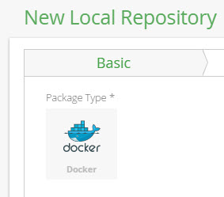

Configuring the reverse proxy.

Step -2

Fill in the details in the following page for a single

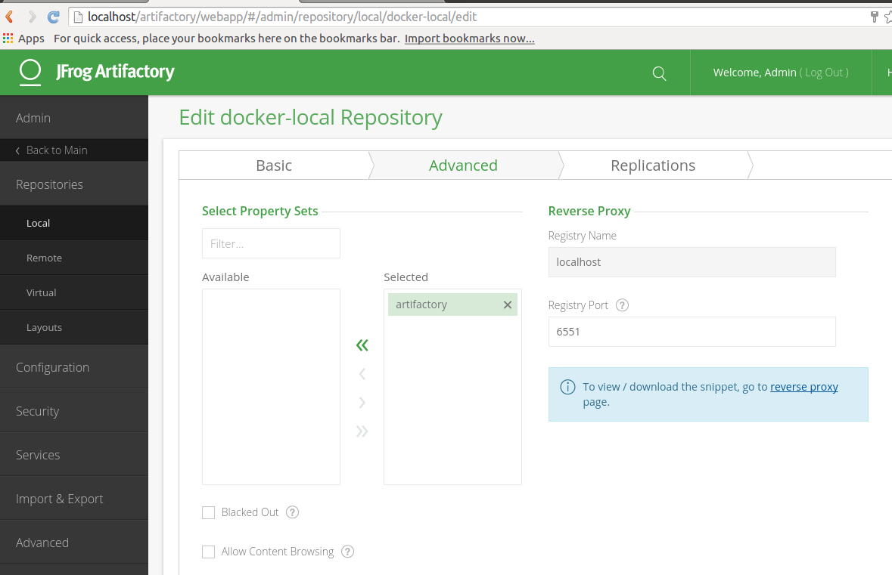

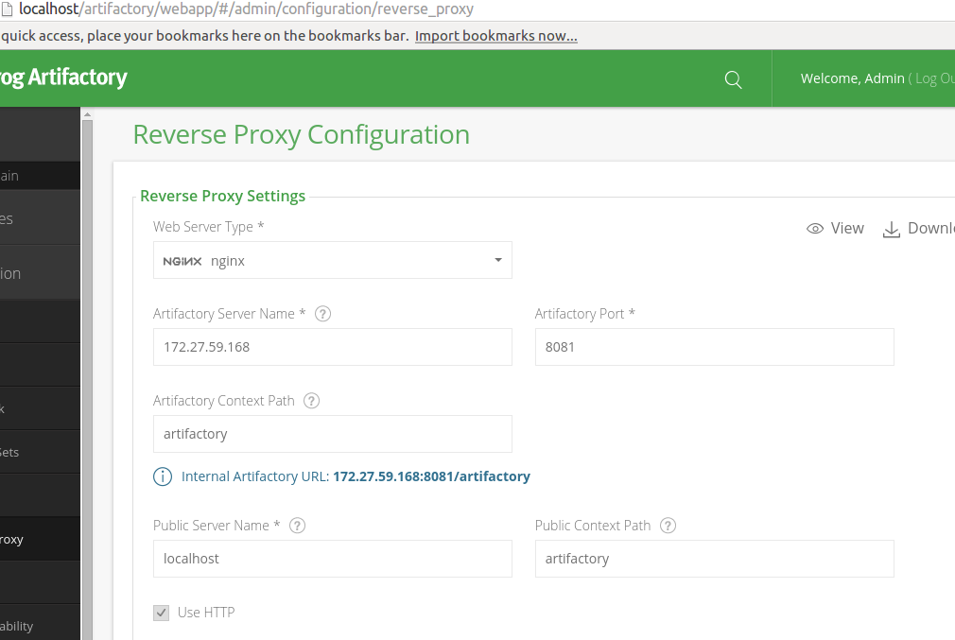

Download the page of reverse proxy.

Install nginx in your machine.

Apt-get install nginx

Edit /etc/nginx/nginx.conf file

Add under http the contents of reverse proxy page.

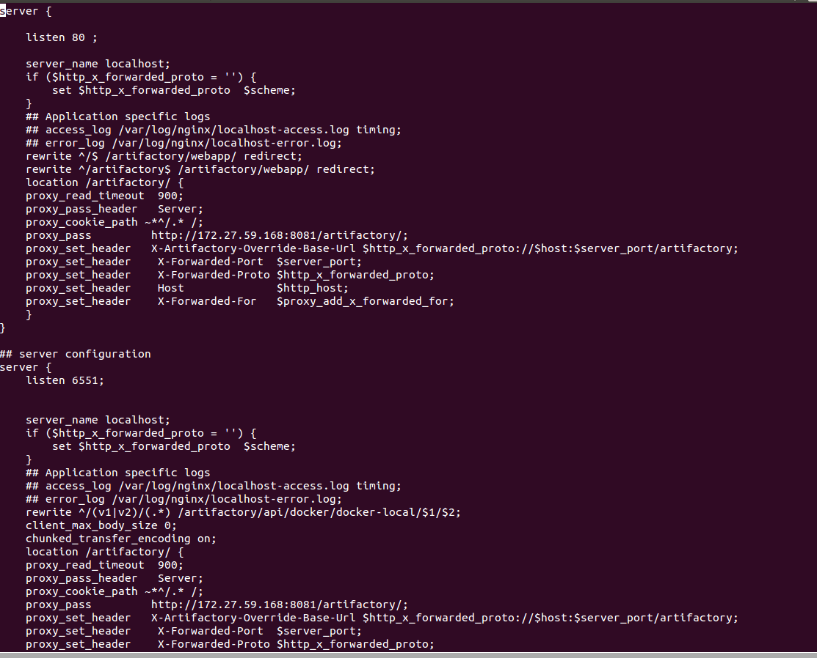

Restart the nginx server.

Step -3

### Setting Up Authentication

Artifactory may be configured to [allow anonymous access](https://www.jfrog.com/confluence/display/RTF/Configuring+Security#ConfiguringSecurity-AllowAnonymousA). This lets you provide access to users who have not logged in (according to permissions you define for anonymous access). While this is a global setting in Artifactory, you can override it specifically for Docker repositories.

For the basic case set-up the anonymous access permission to your repository as explained above for Artifactory as a image.

Step -4

Following steps to be followed for pushing to repository similar to Artifactory image.

* First set insecure registry flag in /etc/default/docker file so as to access by http not https inside
* docker tag image localhost:port/image
* docker push localhost:port/image